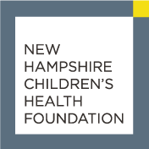

Sandi Van Scoyoc Legacy Award Nomination

Information About Nominee
Individual Organization

Name

Position

Organization

Address

Telephone

Email address of nominee or contact person at nominated organization

Information About Nominator

Name of person making the nomination

Telephone number

Email address

Area of Commitment or Innovation

Which of the New Hampshire Children’s Health Foundation’s priority areas has the nominee advanced?
Reducing or preventing childhood trauma
Increasing access to children's health insurance coverage
Promoting oral health
Promoting healthy eating or active living

Supporting Detail

In two pages or less please tell us why the nominee is worthy of recognition. Specifically:

- How the nominee has demonstrated an exemplary and aspirational commitment or innovation to improve the health and wellness of children and families.
- The impact the nominee or the nominee’s work has had on the community.

Please email this form and supporting detail to
applications@NHChildrensHealthFoundation.org.

